**The role of present-day speciation in modern dynamics of vertebrate diversity**

Alternative title: Present-day speciation rates do not generate modern terrestrial vertebrate cradles and museums

Alternative title: Present-day speciation rates do not generate modern dynamics of terrestrial vertebrate diversity

Alternative title: Recent tetrapod cradles are not the result of present-day speciation

Alternative: Is recent speciation rate the driver of modern diversity dynamics? A global assessment with terrestrial vertebrates

Alternative: Modern dynamics of vertebrate diversity: the role of present-day speciation rates in shaping cradles and museums.

Abstract

Evolutionary and ecological dynamics differ across regions of Earth and across clades of tree of life.

Introduction

The evolutionary and ecological processes underlying global patterns of biodiversity have always been a central subject of study for evolutionary biologists. Much of today's discussion about the geography of biodiversity dynamics stems from theoretical and conceptual developments on the characterization of regional conditions leading to different ways of diversity assembly (Fischer 1960; MacArthur 1964). The study of geographic patterns of species diversity, and particularly the ubiquitous increase in species richness from temperate to tropical regions (i.e., the latitudinal diversity gradient), has led the macroecological discussion from the very beginning of evolutionary biology as a discipline, being among the major topics in the works that paved the way for the modern evolutionary theory (Humboldt and Bonpland 1807; Darwin 1859; Wallace 1876).

The biodiversity levels in a given area are ultimately determined by three fundamental processes: lineage origination (generally represented by speciation in macroevolutionary studies of extant taxa), extinction, and dispersal (REF). These processes, and therefore the differences in richness across geographic and phylogenetic contexts, might be subjected to multiple biotic and abiotic factors, such as ecological interactions (REF), evolutionary time (REF), ecomorphological dynamics (REF), environmental conditions (REF), climatic trends (REF), or topography and plate tectonics (REF). In recent years, the emergence and development of what is known as spatial phylogenetics (Mishler 2023) has fostered the advancement of our understanding of macroecological dynamics by integrating the phylogenetic component into the study of geographic biodiversity patterns. Specifically, the use of phylogeny-based metrics of biodiversity such as phylogenetic diversity (PD) allows for the investigation of the relatedeness of biodiversity across geographic scales. This, in turn, may greatly enhance our ability to understand the evolutionary, ecological, and environmental factors that shape diversity dynamics (Davies and Buckley 2011), as well as being an essential source of information for conservation purposes (Faith 1992).

Another advantage of the development of phylogenetic methods…thing that we can do with phylogenies is inferring the diversification dynamics of groups, and check if the uneven geographic patterns that we observe today are produced by differences in speciation and/or extinction rates.

Even though richness and PD are in general positively correlated, spatial patterns of the two are not exactly coincidental (e.g., REF). In other words, there are geographic areas that harbor higher and lower PD than expected for their richness levels – i.e., areas where species are more distantly or more closely related, respectively, than would be predicted by the number of species (Fig. X).

The terms 'cradles' and 'museums', referring to regions of high instability, heterogeneity and species turnover (cradles) and regions of long-lasting environmental stability and taxonomic diversity (museums) have been very popular in the macroecology literature since Stebbins [-@Stebbins1974] proposed this metaphor. Even though the dichotomous interpretation of these terms has resulted in an inappropriate simplification or directly in a wrong use [@Vasconcelos2022], it is still important to identify the geographically uneven distribution of diversity dynamics to search for their ultimate historical, ecological, and evolutionary drivers.

Meseguer et al. 2022 and others by Meseguer (GEB 2018, GEB 2020, Evolution 2020).

The modern use of the terms museum and cradle and their original meaning [@Vasconcelos2022].

Whether these particular words are used or not, there are regions that show clearly distinct diversity patterns in terms of number of species (species richness) and how closely related those species are (phylogenetic diversity), indicating the existence of differences in their evolutionary dynamics. Although the geographic patterns of species richness and phylogenetic diversity are ever more well-characterized, the role of different factors in generating such patterns is not clear in most cases. Diversification rates, and (in the light of the methodological difficulties of studying extinction at global escales) more particularly speciation rates, are one of the most frequently invoked factors when characterizing biodiversity patterns, but their effect remains ambiguous in the context of global patterns of vertebrate diversity.

In this study, we use global distribution and phylogenetic data for the major clades of terrestrial vertebrates (amphibians, birds, mammals, and squamates) to characterize the geographic patterns of tetrapod diversity dynamics. Specifically, we identified areas that, based on their richness and phylogenetic diversity levels, can be considered as “cradles” (here used as regions of especially low phylogenetic diversity relative to their richness, or low residual PD) and “museums” (here used to refer to regions of high residual PD). We are aware of the ongoing debate on the use of these terms [@Vasconcelos2022], and we agree with the detrimental effect of their wrong or deficient use, as well as with the prioritization of investigating the processes driving biodiversity patterns. Therefore, our primary goal is to characterize diversity dynamics (independently from the use of specific terms) and, more importantly, to explore factors that could be generating such patterns. Particularly, we aim to determine the role of recent speciation and other factors (e.g., time, environment) in generating the present-day distribution of tetrapod diversity dynamics.

Materials and Methods & Results

We calculated phylogenetic diversity (PD): how related species in a region are.

with 100 trees from the posterior (tree_samp100.rds), and get the average values across the 100 grids.

Then, we did a local regression (LOESS) of PD versus species richness. The linear model residuals show regions with high or low phylogenetic diversity accounting for species richness (residual PD). High residuals means high PD for a given richness (museums), while low residuals show low PD (pumps).

We also calculated spatial DR, a measure of current speciation rates, averaging the values obtained for the posterior trees (100 trees).

We identified focal regions of high and low residual PD, representing putative museums (distantly related species) and putative cradles (closely related species), respectively.

LTT plots (potential effect of time/age on present-day diversity dynamics)

I don’t think there are any patterns that we can discuss just by looking at the plots, apparently there are no clear differences between museums and cradles in their way of faunal build-up (we would need fossils to look at the full picture of lineage accumulation). I am not sure that analyzing the data in some manner would help in the interpretation.

Environmental variables

Potential effects of climate and environment on current diversity dynamics.

Temperature and precipitation

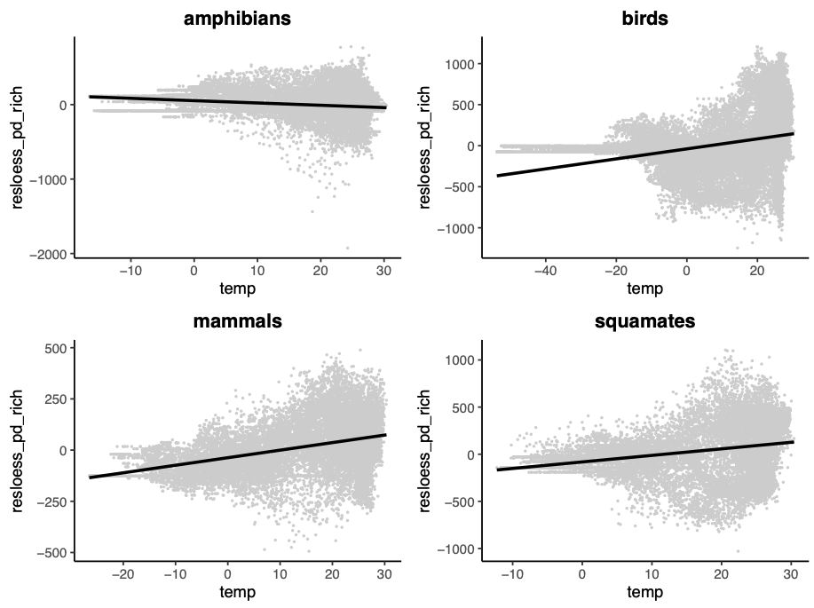

Residual PD vs Temperature. R2: amphibians 0.032, birds 0.09, mammals 0.14, squamates 0.065.

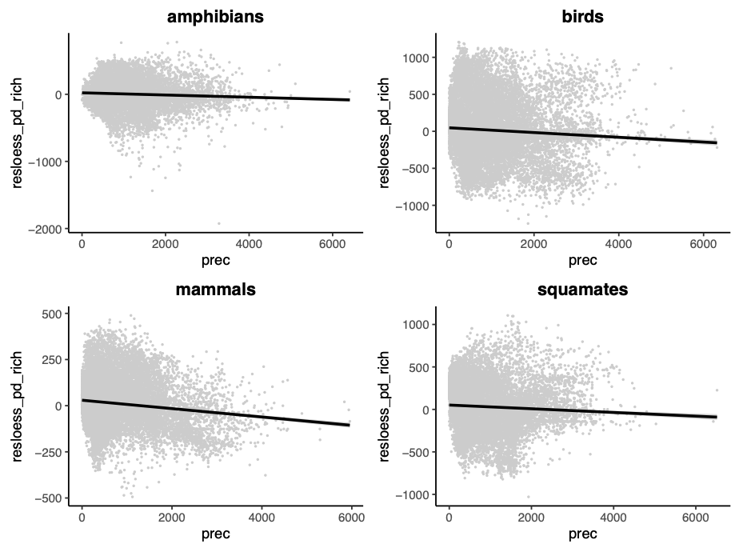

Residual PD vs Precipitation. R2: amphibians 0.004, birds 0.005, mammals 0.017, squamates 0.004.

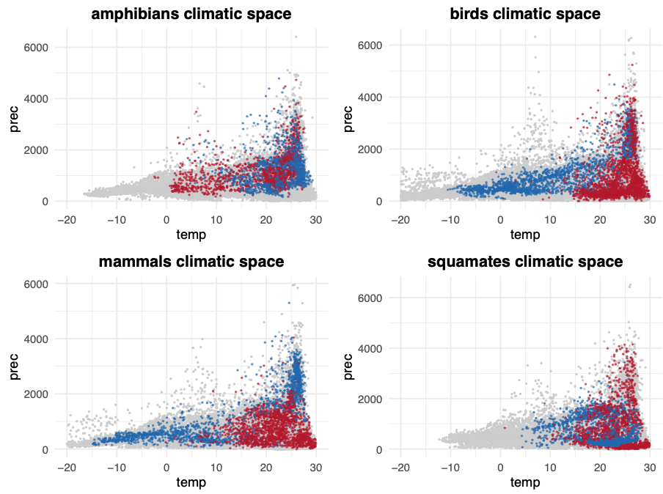

Climatic space (temperature vs precipitation) of cradles (blue) and museums (red) for each group of tetrapods.

Temperature and precipitation seasonality

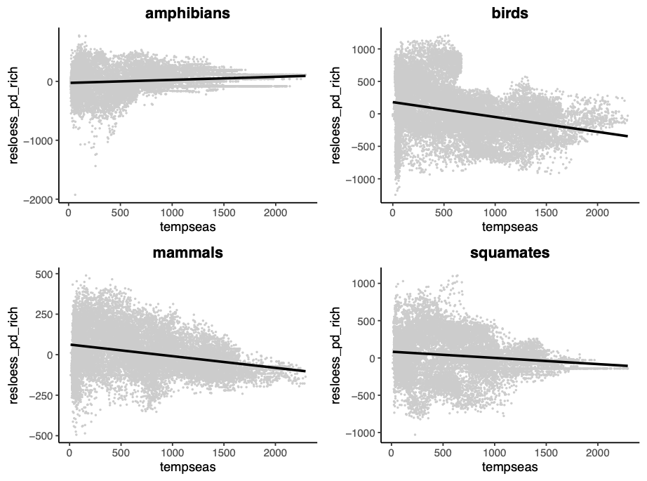

Residual PD vs temperature seasonality. R2: amphibians 0.018, birds 0.09, mammals 0.08, squamates 0.018.

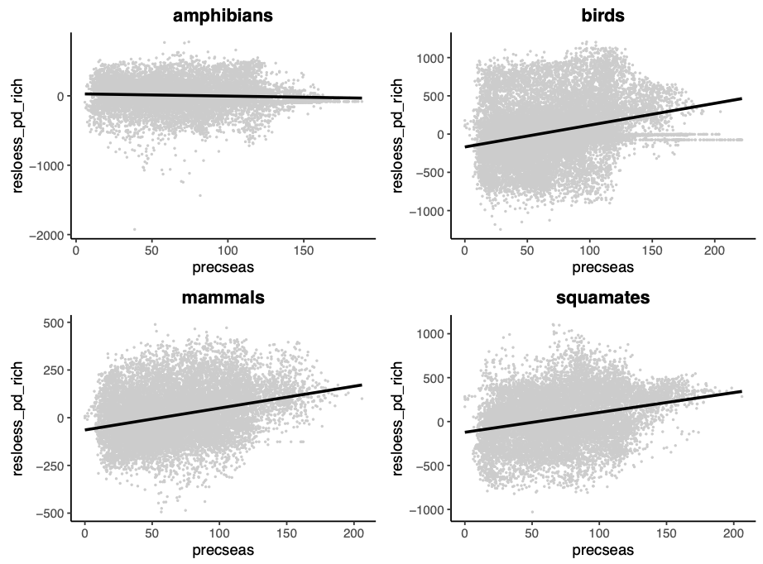

Residual PD vs precipitation seasonality. R2: amphibians 0.003, birds 0.077, mammals 0.092, squamates 0.080.

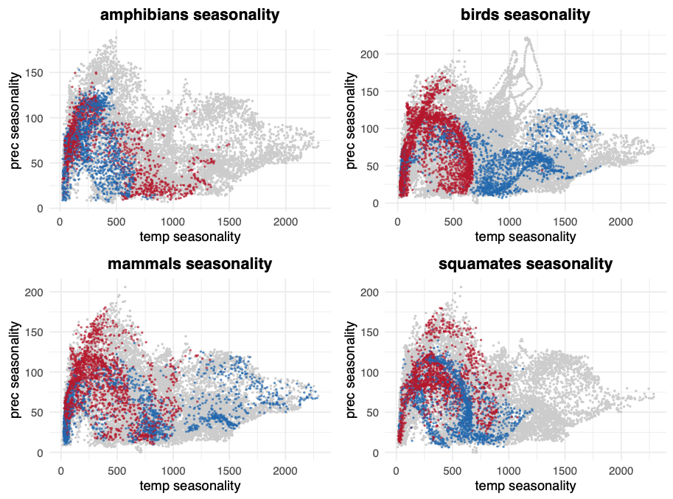

Temperature seasonality vs precipitation seasonality of cradles (blue) and museums (red) for each group of tetrapods.

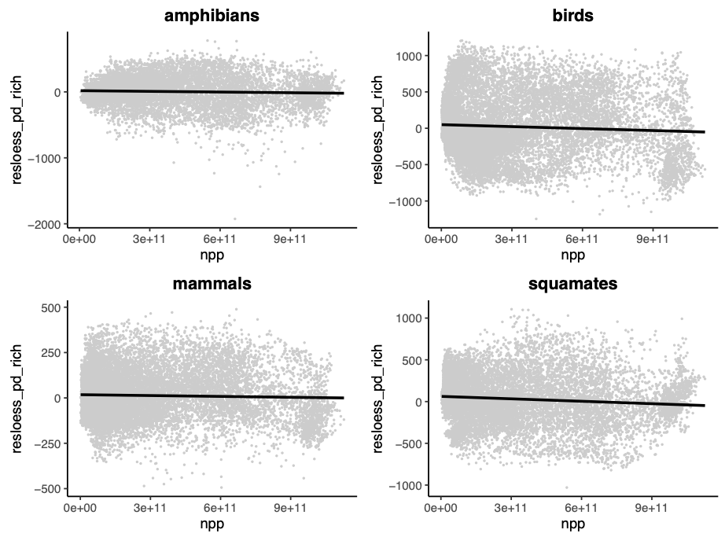

Residual PD vs Net Primary Productivity. R2: amphibians 0.002, birds 0.004, mammals 0.001, squamates 0.01.

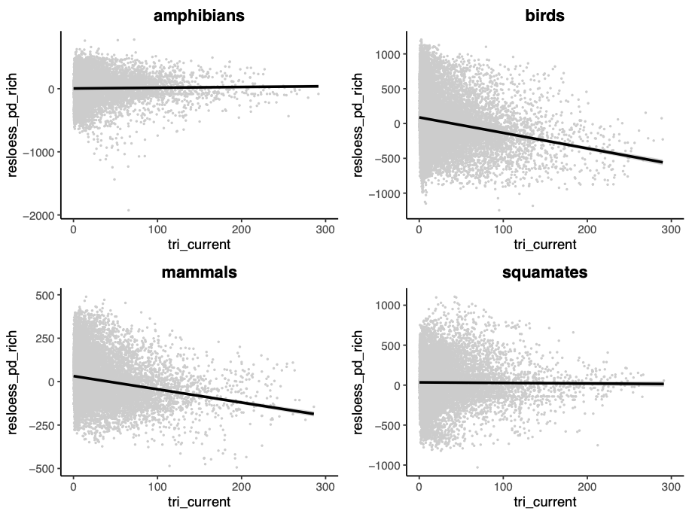

Residual PD vs Topographic complexity (tri). R2: amphibians 0.0004, birds 0.0397, mammals 0.0414, squamates 0.00008.

Latitude plots

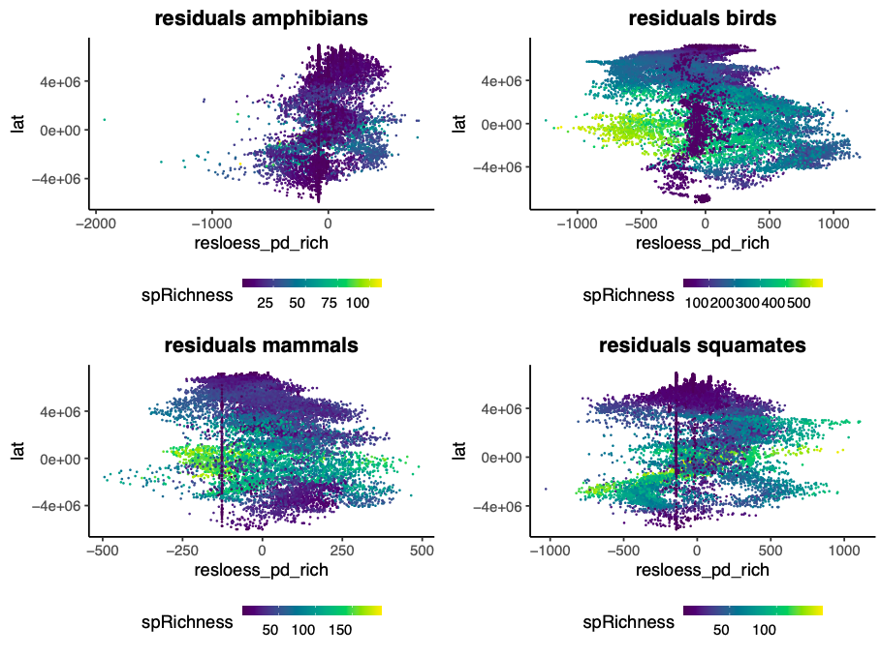

Latitudinal gradient of residuals (PD ~ richness) colored by richness. Positive residual values indicate high PD relative to richness in the grid cell (museums in the extreme positive values). Negative values indicate low PD relative to richness (cradles in the extreme negative values).

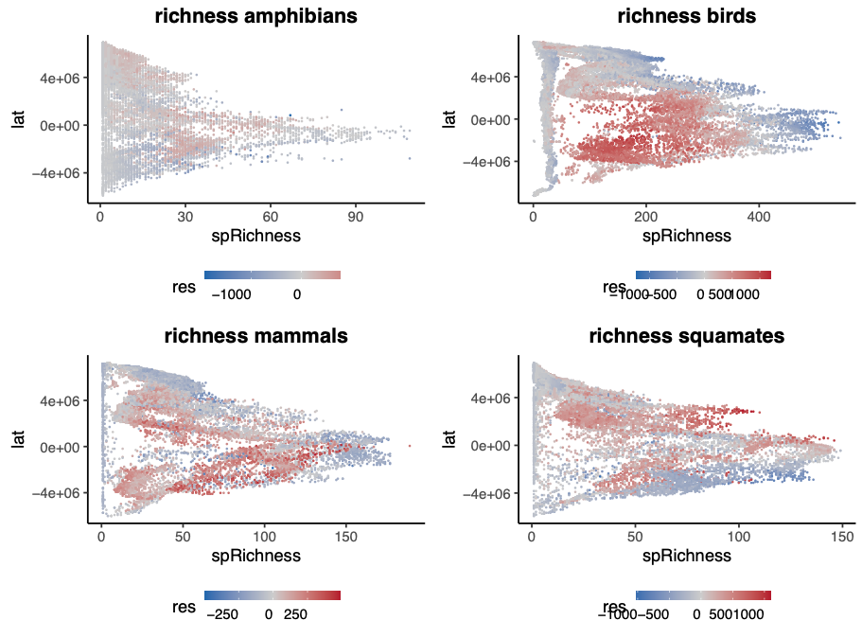

Latitudinal diversity gradient colored by residuals (PD ~ richness): cradles in blue and museums in red.

Richness vs residuals (PD ~ richness) (very low R2).

Speciation rates

Speciation rates of species found in cradles and museums

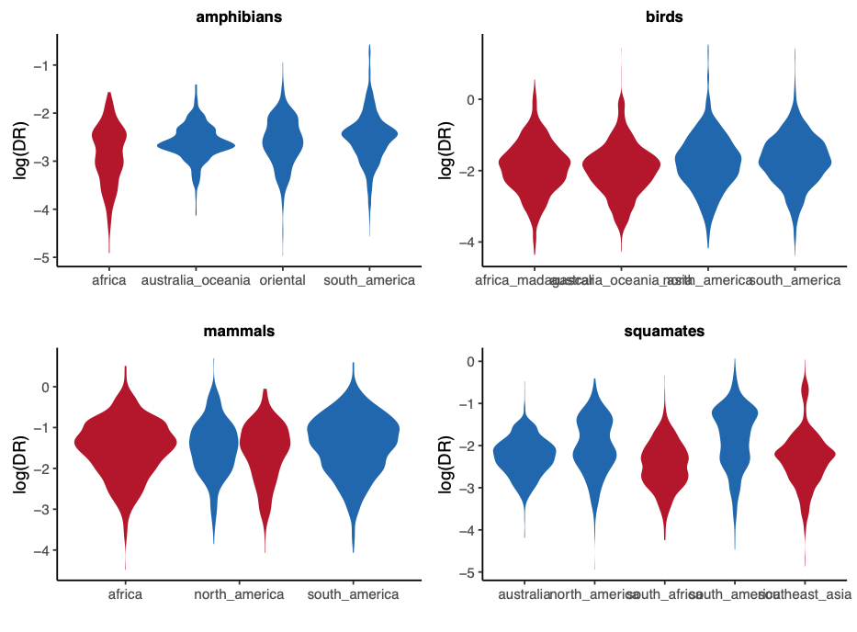

In general, speciation is faster in cradles than in museums, but the effect size is not large.

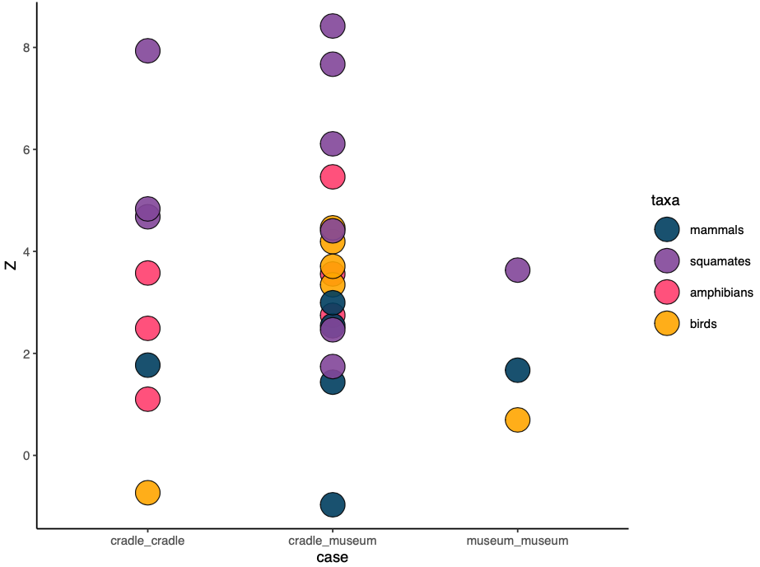

Comparison of speciation rates between cradles and museums (are the differences between cradles and museums larger than between cradles and between museums?). The difference found between museums and cradles is not that different to the difference found between cradles and between museums.

Discussion

The use of PD-based metrics to investigate evolutionary dynamics (spatial phylogenetics, Mishler 2023 JBI).

Our results for mammals are broadly congruent with previous results (Davies and Buckley 2011).

We did not find the expected differential pattern of lineage accumulation between regions of high and low residual PD (i.e., museums and cradles, respectively) (LTT plots). However, the geographic patterns of residual PD might be partially derived from the richness levels of ancient lineages (i.e., species richness in the past). In mammals, for instance, this would reflect that many of the extant clades have an African origin (Lillegraven et al. 1987), making Africa a museum of diversity, while richness in South America is much younger as a result of the recent diversification of multiple current clades following migration after the formation of the Isthmus of Panama and the extinction of old lineages (Davies and Buckley 2011; GABI references: Webb 1976; Webb 2006), resulting in a cradle in this region.

It seems like there is some segregation in the climatic space (temperature vs precipitation) between museums and cradles, at least for some groups (especially birds and mammals), although the relationship between the climatic variables and residual PD is low.

Lack of effect of speciation on other diversity patterns.

Factors that may shape biodiversity dynamics.

Dispersal.

Extinction.

The fact that the places with high speciation rates at present are not the places with more closely related diversity relative to their species richness might indicate that historical diversification trends (rather than present-day processes) are driving geographical patterns of global diversity. This, in turn, may indicate that present-day geographic patterns of speciation might be more related to future biodiversity dynamics (Schluter and Pennell 2017).

Another interesting point might be that museums do not consistently coincide with desert regions, which are often considered sinks of biodiversity (Crisp et al. 2009). In fact, some deserts might be sources of diversity like the mammal and bird cradles in North America, and the squamate cradles in North America and Australia (Fig. MAP). This is consistent with previous results on arid lizards in North America (Wiens et al. 2013).

Something about mountains?

References

**Figures (in folder figs)**

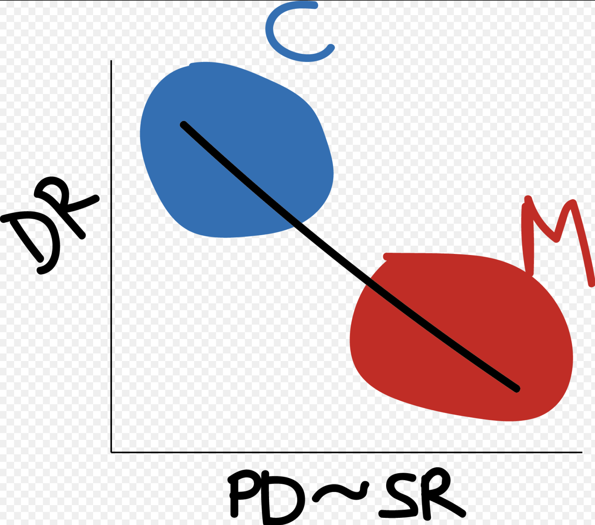

Figure 1. Conceptual representation of the expected relationship between speciation rates and phylogenetic diversity (PD) relative to species richness.

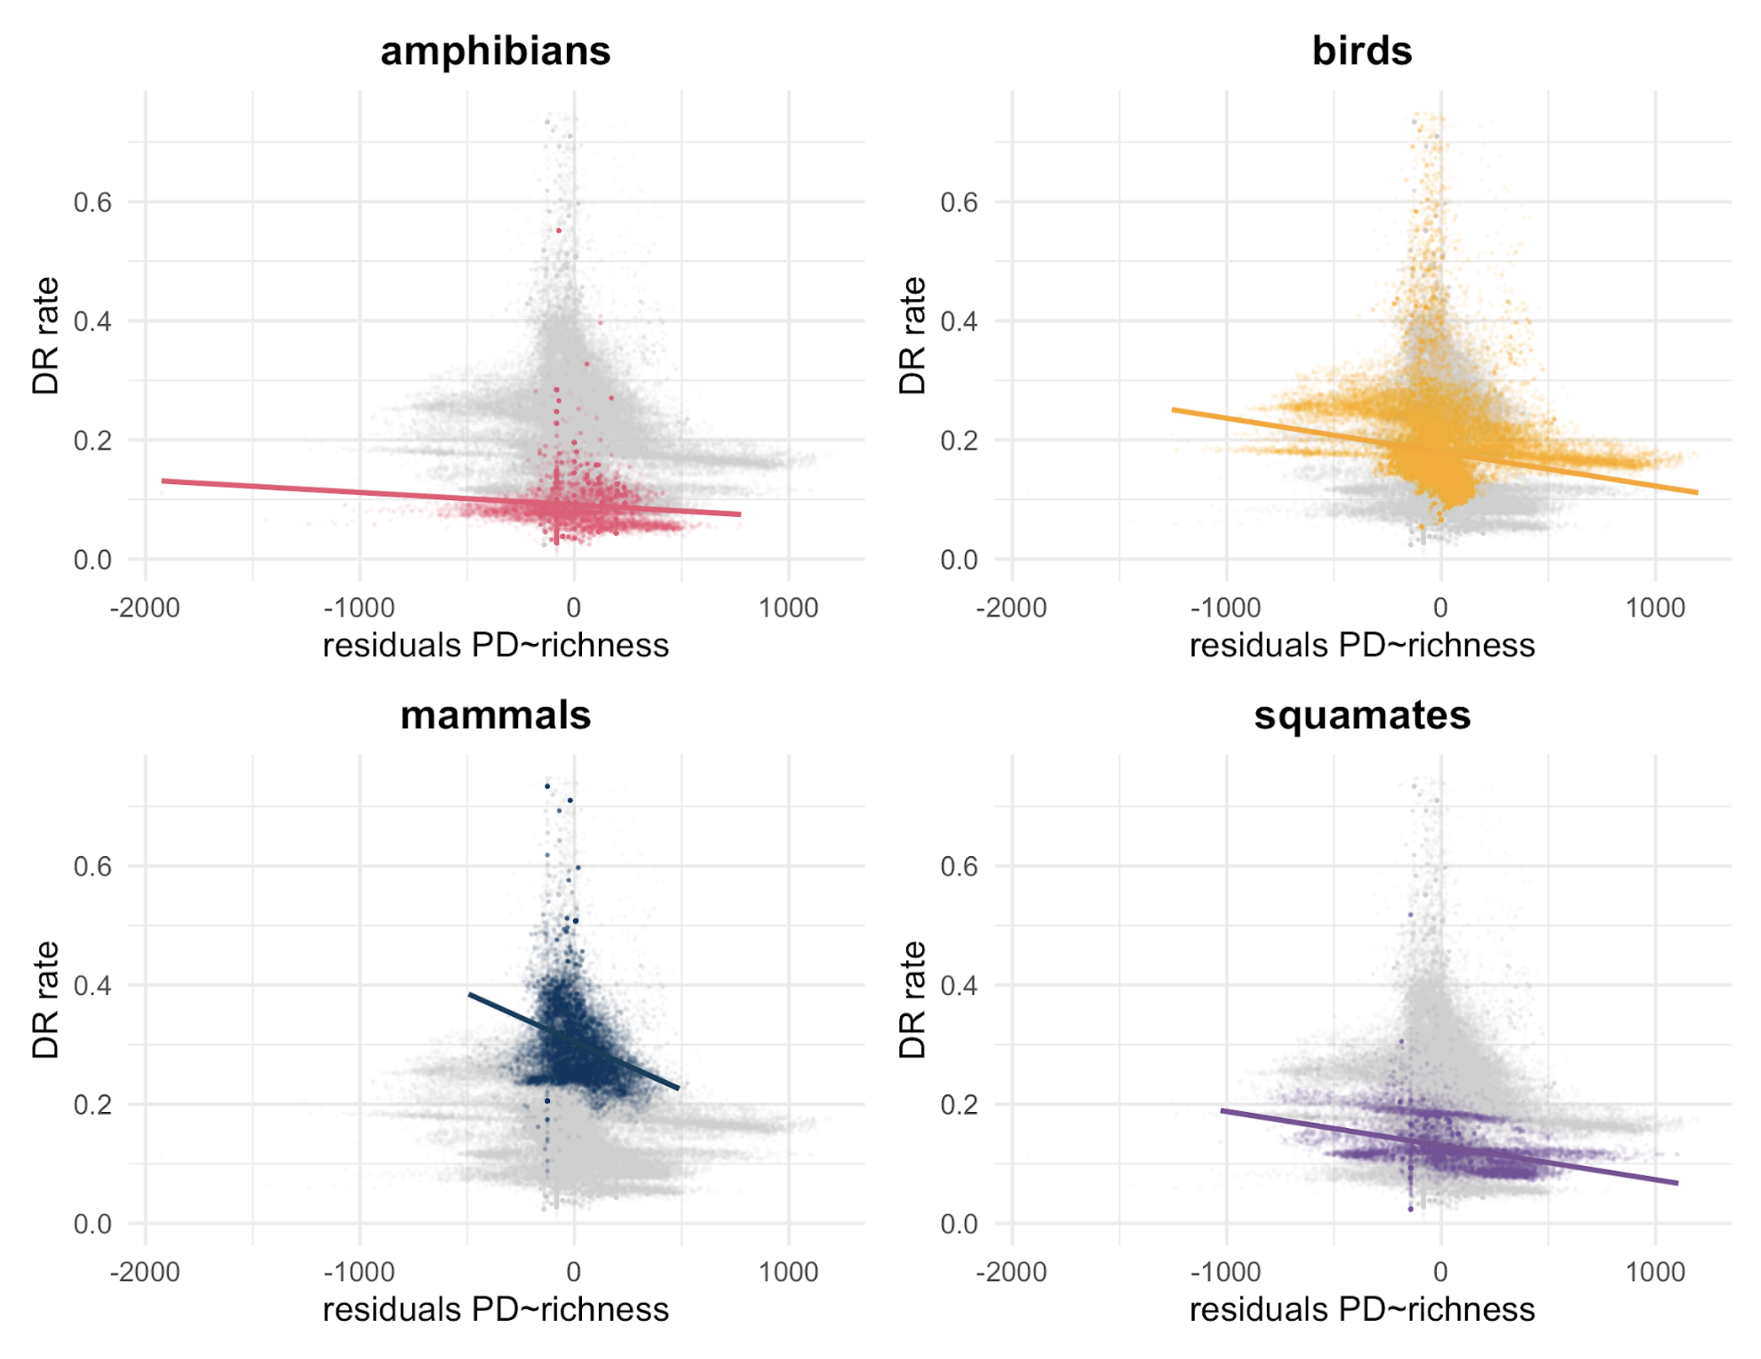

Figure 2. Relationship between DR rates and the residuals resulting from a regression of `PD ~ Richness` for all four groups of terrestrial vertebrates.

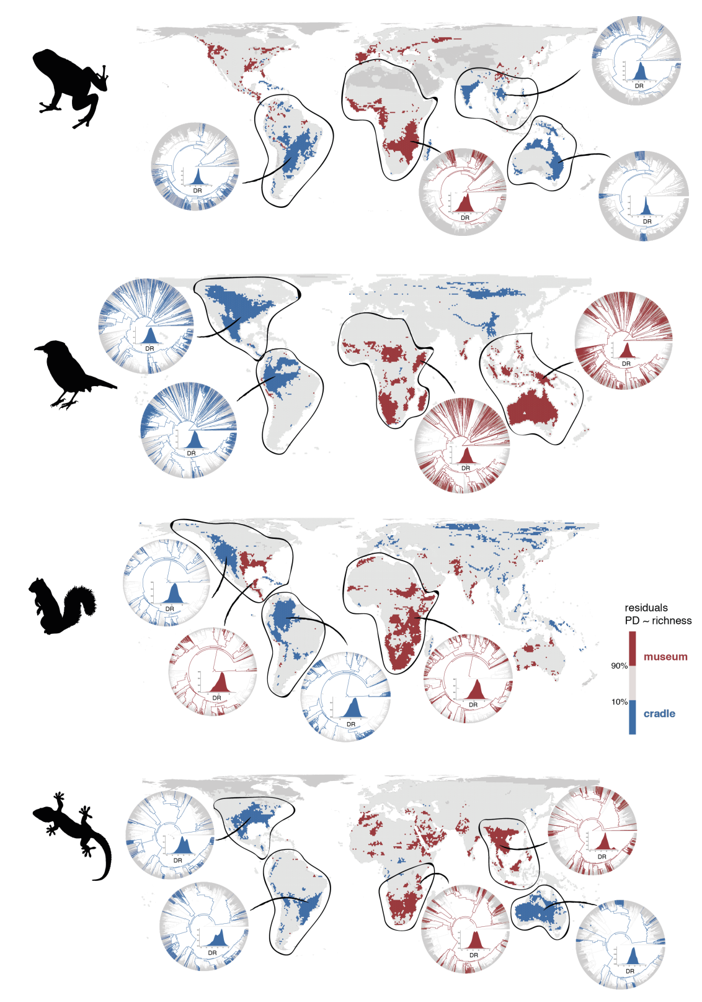

Figure 3. Geographic distribution of cradles and museums for terrestrial vertebrates. Silhouettes extracted from 'phylopic' (www.phylopic.org).